PyCamp Class 1 HW

REMEMBER TO SAVE A DUPLICATE COPY BEFORE EDITING - RK

# Questions

1. Who created python, and when was python released?

Guido van rossum

Guido van Rossum created Python and it was released in 1991

1. What is python mainly used for?

*Like for software programing*

1. What are the three ways that python can be treated?

Python can be treated in a procedural way, an object-oriented way or a functional way.

1. What is the latest version of python?

The latest version ofd python is python 3

1. What is an IDE?

*a computer program*

1. Briefly, define String.
2. String is like a arra of bytes in python.
3. Briefly, define Integer and Float.
4. Briefly, define List and Tuple.

*Delete this text to answer here...*

A list a tuple are just bultiple things or a list of thing.

1. Briefly, define Boolean.

*Delete this text to answer here...*

Boolean is th e true/false code.

1. HARDCORE QUESTION: Describe the steps to make and run a program in repl.it (no need to explain code... just say “write code”). Have a minimum of ten sentences and a max of 15 sentences.

First, open google chrom, then type repl.it and open that up. Then, name your repl and click ”done”. Then. write your code and click run. if you have a mistake in your code, there will be a red sign saying error on your screen. for example if I type= 34(;;;;__ there will be a error because there is no proper code. But if I type print(”hello world”), it will do this: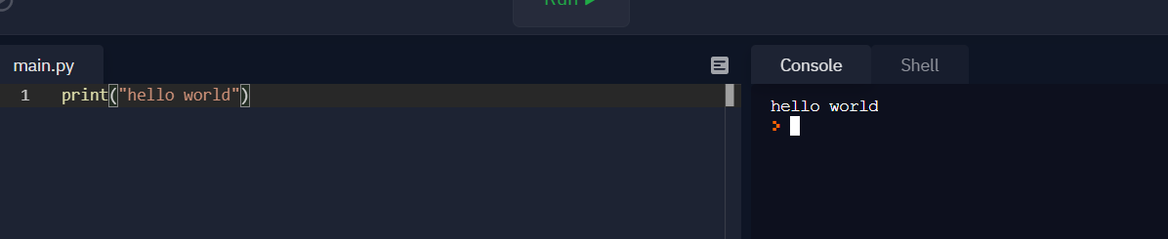

*Delete this text to answer here...*

# Then,

# Coding

Create a repl in repl.it. It should have the following qualities.

The datatypes we learnt today should be in the box. Hint: (for each line put a hash before the line to make it into a comment.)

There should be 5 datatypes in total from today, so type once for each datatype.

Before each datatype, make sure it says what category the datatype is in. Text is TXT, Numeric is NUM, and Sequence is SEQ. After each datatype, make sure it says what the datatypes is. This part doesn’t need any acronyms. (Please don’t have any spaces in the output.)

*Example Input: Example Output:*

# “NUM” + 2.3 + ”Float” None

*Insert a snip of your code’s input, in the box below. (Use Windows-Shift-S to take a snip, and Ctrl-V to paste) (Please shrink to fit into the box)*

*Insert a snip of your code’s output, in the box below.*

*Please copy over the repl’s link into the box below.*